30.76: Series: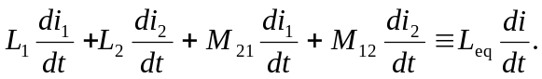
But 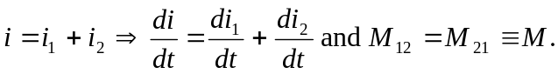
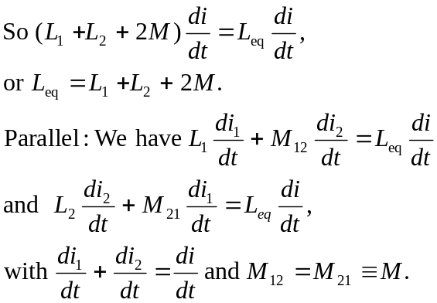
To simplify the algebra let 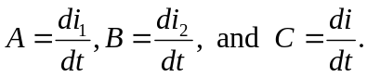
So
Now solve for 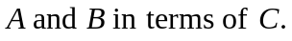
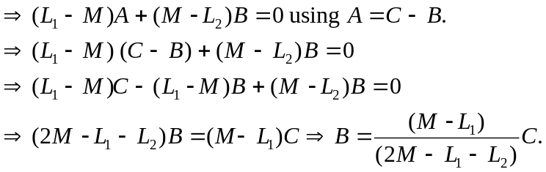
But 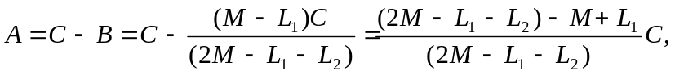
or 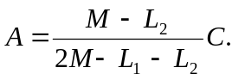Substitute in back into original equation.
So 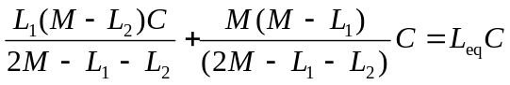
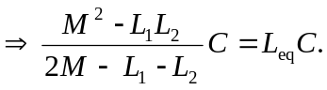
Finally, 